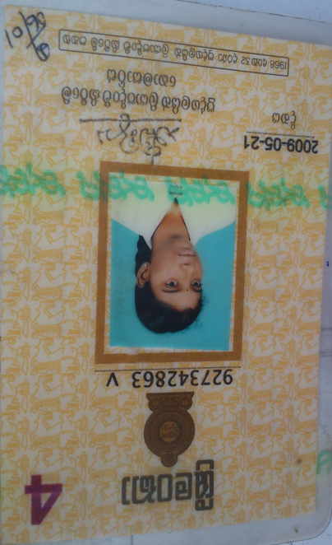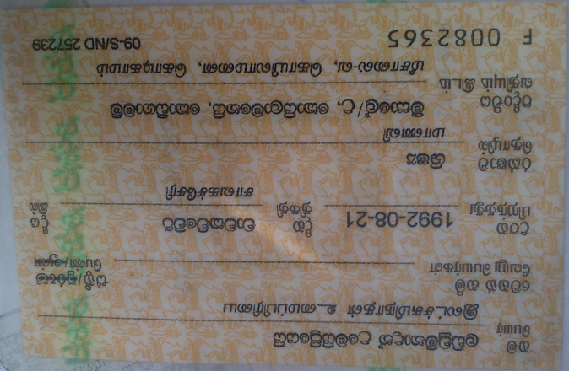



8994032300714382407

Name – Ladchuminadan Umeipriyei

Address – Meesale\U, Koilamanei, Kodigamam.

Contact No – 077 678 1938

Id no – 927342863v

5.5Gb Data Package.